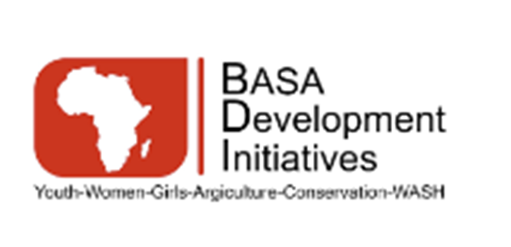
BASA DEVELOPMENT INITIATIVES
Policy on SEA-Specific Reference Checks, Self-Declarations, and Contractual PSEA Obligations

Effective Date: January 15, 2026
Approved by: Board of Directors
Applies to: All personnel and affiliated individuals

Purpose
This policy sets out BASA Development Initiatives’ requirements for conducting Sexual Exploitation and Abuse (SEA)–specific reference checks, obtaining mandatory self-declarations, and embedding Prevention of Sexual Exploitation and Abuse (PSEA) obligations across all personnel engagement modalities. The policy reflects BDI’s zero-tolerance approach to sexual exploitation and abuse and aligns with UNICEF PSEA Minimum Standards, United Nations safeguarding principles, and applicable national laws.

Scope and Applicability
This policy applies to all individuals engaged by BDI, including permanent and temporary staff, consultants, individual contractors, volunteers, interns, board members, advisors, and any affiliated personnel who have access to project sites, communities, or beneficiaries. The requirements apply at recruitment, during contract renewal or extension, and whenever personnel move into roles with increased safeguarding or beneficiary-contact risk.

Guiding Principles
BDI implements this policy in accordance with the principles of zero tolerance for sexual exploitation and abuse, survivor-centered and child-sensitive safeguarding, confidentiality and data protection, risk-based due diligence, fairness, and non-retaliation.

SEA-Specific Reference Checks
BDI requires that all prospective personnel undergo SEA-specific reference checks prior to confirmation of engagement. These checks form part of BDI’s due-diligence process and are designed to identify any past conduct, allegations, or disciplinary actions related to sexual exploitation, abuse, harassment, or other safeguarding violations. Reference checks must be conducted with a minimum of two professional referees and should, where possible, include a direct supervisor. The reference-checking process should cover at least the previous five years of relevant employment or engagement. Referees are asked explicit questions related to safeguarding conduct, SEA allegations, disciplinary history, and suitability for roles involving interaction with communities or beneficiaries. All reference checks must be documented in writing and retained in the individual’s personnel file.

Where SEA-specific information cannot be obtained due to institutional constraints, confidentiality policies, or non-response, the limitation must be clearly documented. In such cases, BDI will conduct a safeguarding risk assessment and may apply additional mitigation measures, including enhanced supervision, restricted duties, or probationary arrangements. No individual may commence duties without documented clearance or approved risk-mitigation measures authorized by senior management.

Mandatory SEA Self-Declaration
All personnel are required to complete and sign a SEA Self-Declaration Form as a condition of engagement with BDI. The self-declaration confirms that the individual has not been found, through due process, to have committed sexual exploitation, sexual abuse, sexual harassment, or other safeguarding violations, and that they have not been dismissed or disciplined for such conduct.
The declaration further confirms the individual’s understanding that providing false or misleading information constitutes gross misconduct and may result in disciplinary action, including termination of engagement and referral to national authorities or donors. Self-declarations are required at onboarding, at contract renewal or extension, and prior to assignment to roles or locations assessed as higher safeguarding risk.

Contractual Embedding of PSEA Obligations
BDI ensures that PSEA obligations are formally embedded in all personnel contracts and engagement instruments. Every employment contract, consultancy agreement, volunteer or internship agreement, or individual memorandum of understanding must include a specific PSEA clause or explicitly reference a signed Code of Conduct that integrates PSEA requirements.
These contractual provisions clearly state that any act of sexual exploitation or abuse constitutes gross misconduct and may result in immediate termination of the contract or engagement, referral to national authorities, and notification to relevant donors, including UNICEF. No contract or agreement may be issued without this safeguard provision.

Confidentiality and Record Management
All information obtained through SEA-specific reference checks, self-declarations, and contractual documentation is treated as strictly confidential. Such information is stored securely in personnel files and accessed only by authorized Human Resources and safeguarding personnel on a strict need-to-know basis. BDI applies appropriate data-protection standards to ensure the privacy, dignity, and rights of individuals are respected at all times.

Roles and Responsibilities
Overall responsibility for implementation of this policy rests with BDI’s senior management. Human Resources is responsible for ensuring that SEA-specific reference checks, self-declarations, and contractual clauses are completed, documented, and properly filed. The designated Safeguarding or PSEA Focal Point provides technical guidance, supports risk assessments, and ensures safeguarding standards are consistently applied. All personnel are responsible for complying with this policy and cooperating fully with safeguarding procedures.

Compliance, Monitoring, and Review
Compliance with this policy is subject to internal monitoring, periodic review, and donor safeguarding assessments. Failure to comply with these requirements may result in corrective action, disciplinary measures, or termination of engagement. This policy shall be reviewed periodically to ensure continued alignment with UNICEF requirements and evolving international safeguarding standards.

